Ideation Phase
Brainstorm & Idea Prioritization Template

Date | 29 September 2026
Team ID | UNM111DJMRP
Project Name | AI FitTrack – AI-Powered Fitness Management and Recommendation System
Maximum Marks

Brainstorm & Idea Prioritization Template:
Brainstorming provides a free and open environment that encourages everyone within a team to participate in the creative thinking process that leads to problem solving. Prioritizing volume over value, out-of-the-box ideas are welcome and built upon, and all participants are encouraged to collaborate, helping each other develop a rich amount of creative solutions.
Use this template in your own brainstorming sessions so your team can unleash their imagination and start shaping concepts even if you're not sitting in the same room.
Reference: https://www.mural.co/templates/brainstorm-and-idea-prioritization
Step-1: Team Gathering, Collaboration and Select the Problem Statement
Project idea | AI FitTrack – a fitness and gym-membership management backend (REST API) with an AI layer (Google Gemini) and a React web client.
Team gathering | Team members met to discuss how gym members currently track workouts, goals and gym visits, and what gym managers need to see. Each member contributed ideas independently first, then ideas were shared, grouped and voted on.
Focus question | How might we give gym members one reliable place to track workouts, goals, attendance and progress – with personalised AI guidance – while giving gym administrators a live view of member activity?
Selected problem statement | Members and managers rely on notebooks, spreadsheets and paper sign-in sheets, so there is no consolidated, real-time view of fitness activity, progress cannot be measured reliably, and members receive no guidance based on their own data.

Step-2: Brainstorm, Idea Listing and Grouping
Workout & Goal Tracking  • Log workouts (name, category, duration, calories, date)  • Edit / delete own workouts  • Search by name, category or date  • Set goals with target value and deadline  • Goal progress calculated automatically from logged data | Gym Attendance  • One-tap check-in / check-out  • Visit duration calculated automatically  • Only one open visit per member  • Attendance history with date filter  • Goals that count gym visits | Progress Analytics  • Totals, average duration, total calories  • Workout streaks (current / longest)  • Consistency % over last 30 days  • Category distribution  • Week-by-week progress chart
AI Guidance (Gemini)  • Personalised weekly workout plan  • AI insights from the member's own stats  • Safety tips + non-medical disclaimer  • Never send name / email / IDs to the AI  • Clean errors when AI is busy or unavailable | Admin & Management  • System statistics dashboard  • Members overview with Active / Inactive status  • Gym-wide workouts, goals, progress, attendance  • Promote / demote users, delete users  • Admin cannot change / delete own account | Security & Reliability  • JWT login + bcrypt password hashing  • Role-based access (user / admin)  • Ownership checks (403 on others' data)  • Request validation + field whitelisting  • Central error handling + health endpoint
Grouping result: 6 themes, 30 ideas – core themes become epics in the Product Backlog.
Ideas parked for a future version: chatbot coach, wearable / device sync, nutrition & diet tracking, push reminders, mobile app.

Step-3: Idea Prioritization
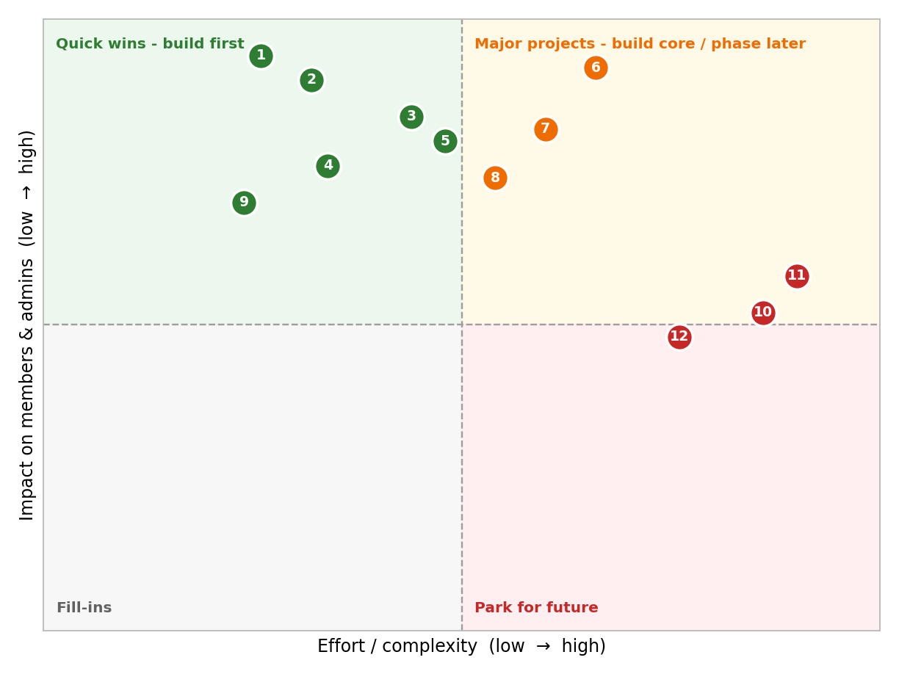
# Idea | Impact | Effort | Decision
1. JWT auth + roles | Very high | Low | Build now (Sprint-1)
2. Workout CRUD + search | Very high | Low | Build now (Sprint-1/2)
3. Goals (server-calculated) | High | Medium | Build now (Sprint-2)
4. Gym check-in / check-out | High | Low | Build now (Sprint-2)
5. Progress analytics | High | Medium | Build now (Sprint-3)
6. AI recommendation | Very high | Medium-High | Build now (Sprint-3)
7. AI fitness insights | High | Medium | Build now (Sprint-3)
8. Admin dashboard & members | High | Medium | Build now (Sprint-4)
9. Validation + error handling | Medium | Low | Build now (Sprint-1)
10. Chatbot coach | Medium | Very high | Future version
11. Wearable sync | Medium | Very high | Future version
12. Nutrition / diet tracking | Medium | High | Future version
Prioritisation rule: build every high-impact / low-to-medium-effort idea first (backend core, auth, tracking), then the AI features, then the admin module; park high-effort, medium-impact ideas.

